Microsoft xml parser manual
- in excel record a macro name it xmltest
- 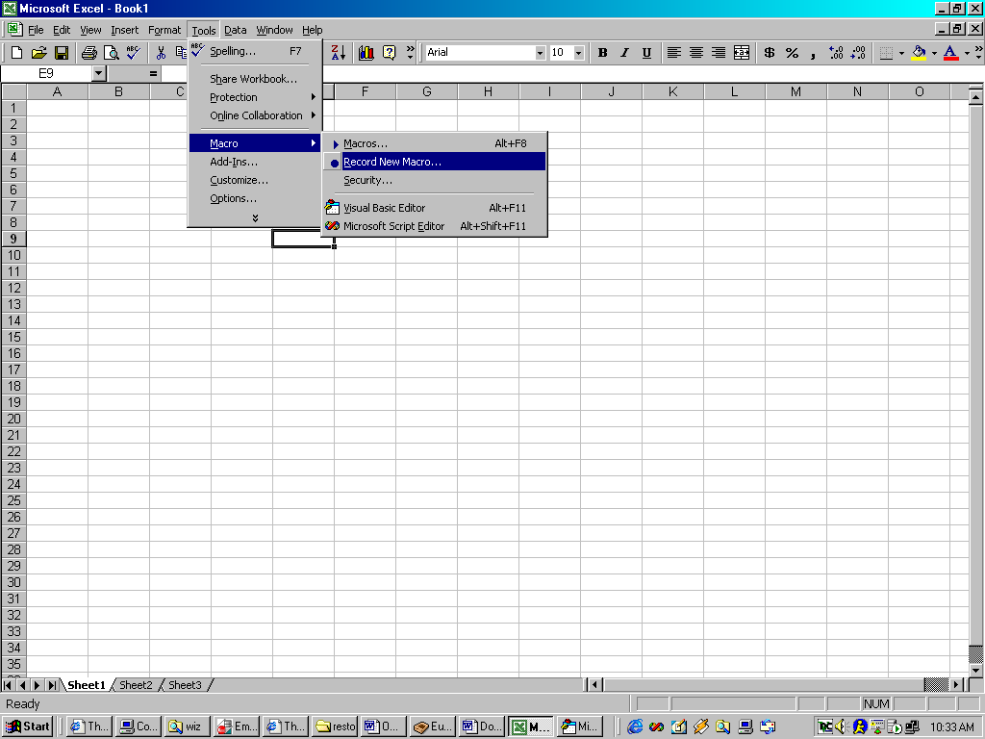
- type some random text. Stop the recording and get into the vba editor (alt+F11)
- 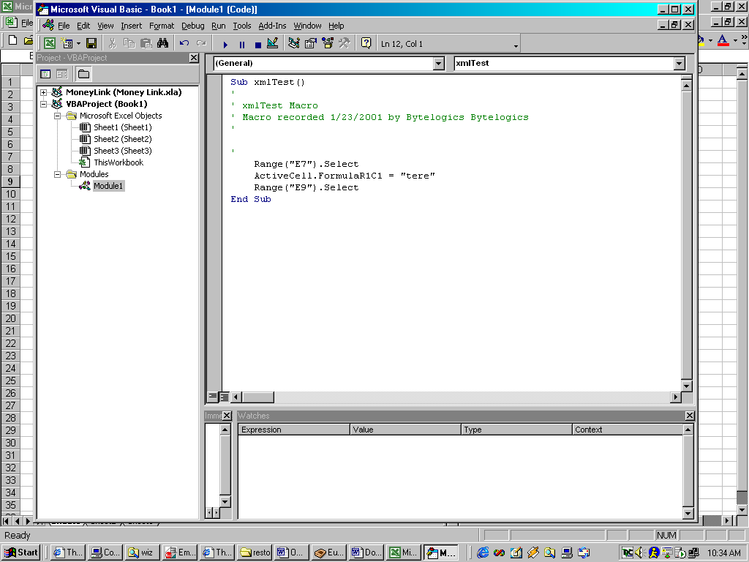
- Find from the menus tools:references and add a reference to the xml parser com dll
- 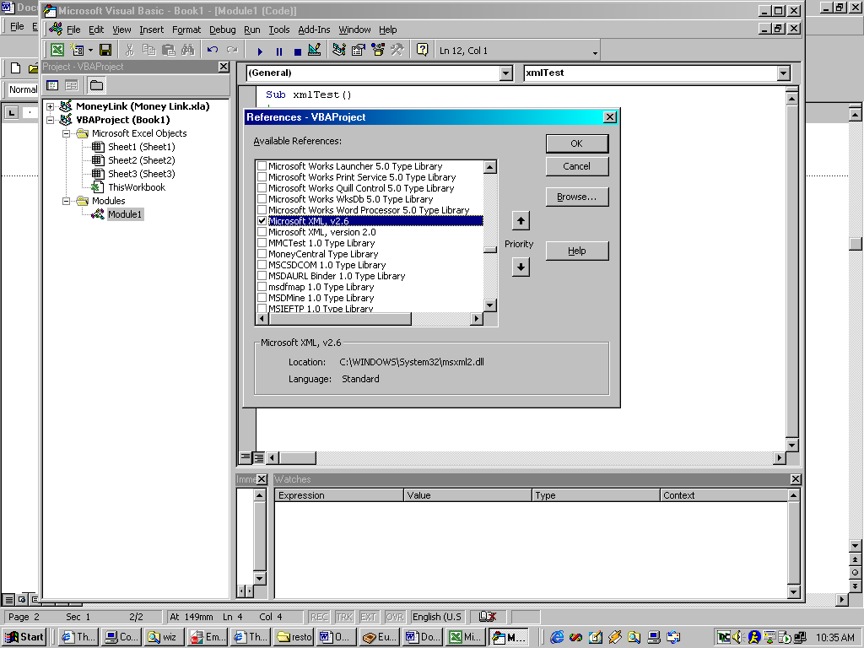
- type XMLHTTP into google.com
- you will get http://www.4guysfromrolla.com/webtech/110100-1.shtml read this
- then copy the code to the macro you are writing, like this (make sure you dim xml as then intellisense will start working)
Dim xml As MSXML2.XMLHTTP
Set xml = New MSXML2.XMLHTTP
xml.Open "GET", "https://gs.com/xmlgenerator?user=keith"
xml.send
Dim doc As MSXML2.DOMDocument
Set doc = New MSXML2.DOMDocument

doc.Load xml.responseXML
Dim r As Range
Set r = Range("a2")
r.Value = doc.xml
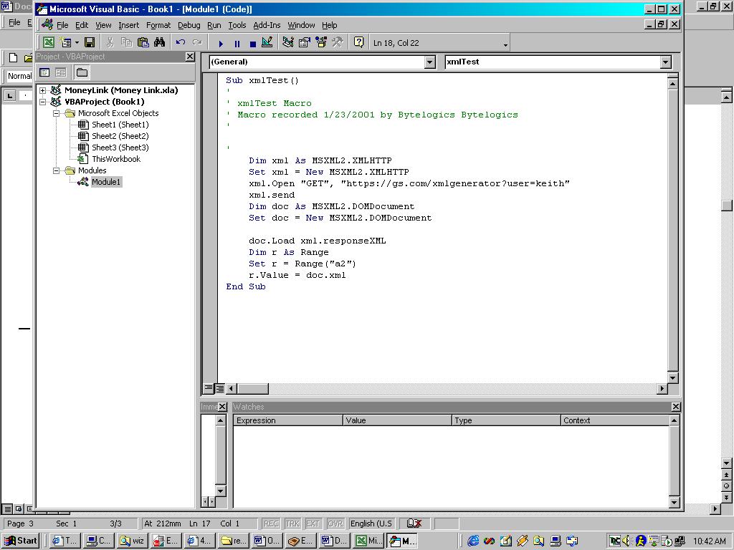

If you need https you might need an updated xml parser com dll. It is on http://msdn.microsoft.com/downloads/default.asp?URL=/code/topic.asp?URL=/msdn-files/028/000/072/topic.xml

Or www.microsoft.com/xml for short
Make sure you also get the xmlinst.exe tool as you will need it if the computer starts behaving badly.
Key is in the MSXML2.XMLHTTP
The way com works is that you have a default version (MSXML2) and then the real versions (MSXML2.26 MSXML2.3 etc) so you can use MSXML2.3.XMLHTTP

So once you install 3.0 you can set default back to 2.6 but still use the 3.0

Just search the registry for MSXML and you will get the idea.

