The concept of the NAIRU has become meaningless for any reasonable understanding of the determinants of either inflation, or unemployment.

In this essay I will try to evaluate the relationship between unemployment and inflation. The relationship itself has gone through numerous modifications, the one now being expressed by the NAIRU that moves around. Although almost impossible to answer, the main question of this essay will be whether there is a NAIRU that is affected by several factors, or whether these factors influence inflation directly.

NAIRU is made up of two parts, the part being explained by the search theory, arising from natural imperfections in the market, called the natural rate and the part artificially created by people, mostly unions. As the influence of unions has been drastically reduced over the past 20 years, the concept of NAIRU has become very similar to natural rate. However, as there are numerous labour laws introduced, that has increased the volatility of natural rate, meaning it is not something “naturally fixed” anymore.

The natural rate can be explained by the search theory. Classical theory predicts employment based solely on real wage, and reaches the conclusion that labour markets should always clear – meaning no unemployment. One can however extend the theory to account for the fact that employing a new person costs money to the firm – money not paid as a wage to the employee. The cost of hiring workers is equal to a fixed number (C) that is taken as given by firms. But in reality the cost of hiring workers depends on the number of other firms that are also looking for workers. I shall take L’ to mean the number of workers employed (on average) by all of the firms in the economy and symbol L to mean the labour employed by one particular firm. The important element in the search model then is that C depends on L’ and that this cost gets very big as unemployment gets very small. The fact that costs of search get big, as employment increases, means that in the search model firms will not be able to profit in equilibrium by hiring unemployed workers at a lower wage. There is an equilibrium rate of unemployment that is called the natural rate. On figure 1, the downward sloping curve is the labour demand curve for the economy as a whole. This is just the same as the demand curve for a single firm added up over all of the firms. Following Roger E. A. Farmer I will simplify that the labour supply does not depend on the real wage. The wage w^{E} is the one that would prevail in a classical model in which there are no search 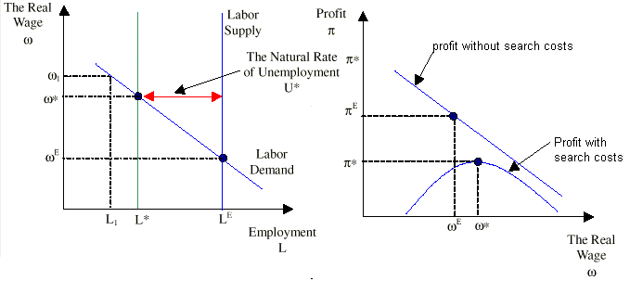costs. The wage w* is the one that prevails in the economy where search is costly.
Figure 1 Figure 2

Figure 1 illustrates the demand and supply of labour. In the classical model there are no search costs and employment is at LE where the quantity of labour demanded equals the quantity supplied. In the economy with search costs, employment is at L* where no firm can profit by offering to buy labour at a lower wage. The real wage is at w* above the classical real wage, w^{E} and U* people are unemployed. This is called the natural rate of unemployment. Figure 2 illustrates why w* does not fall to clear the labour market. If firms hire more workers they increase the costs of other firms. This increase in costs lowers profits. When w = w* no firm can make extra profit by offering a lower real wage.
If the wage is higher than w* (w1), then at this real wage unemployment is higher than the natural rate U* and there is an incentive for firms to employ more workers and to offer them a lower real wage. Hiring extra workers doesn’t make much difference to the search costs of other firms – there are still plenty of workers to go around. When unemployment falls it becomes more difficult for firms to hire workers and the costs rise. This additional cost works in the opposite direction to the forces that cause profit to increase as the real wage falls and, eventually, the number of unemployed workers is so small that the increased costs of searching for workers outweighs the benefit to the firm of lower wages. When this point is reached the real wage is equal to w*, unemployment equals U* and L* workers are employed. The figure 2 depicts the profit level for firms for employing extra workers. When the real wage is very high search costs are not very important and as the wage falls profits increase because firms benefit from lower labour costs. But as aggregate employment increases, the additional search of each firm makes it harder to find new workers and, the cost C to each individual firm gets bigger. Eventually, as the economy gets close to full employment, the congestion costs of more searchers dominates the private benefits to the firm of paying lower wages and at this point, profit begins to decline as the real wage falls further.
The main innovation that Keynes introduced to the theory of employment was to argue that in practice the unemployment is rarely at its natural rate. I am not very good at the history of economic thought, because most of the ideas were later proved to be unjustifiable by empirical research, so I will not explain the exact link that Philips described for why the low unemployment causes inflation. However, mainly it was due to people asking nominal wage increases, these leading to increases in price level and to little change in real wage – meaning even bigger money increases. Some researchers in adaptive expectations say that any unemployment that is different from the natural rate will make the inflation increase exponentially, as people will have expectations of inflation already, and they when demanding a real wage increase, they will incorporate the expected inflation to their wage claims. However, empirical research ahs not found this to be significant, thus a rule of thumb is used whereby an unemployment 1% below the natural rate will increase inflation by 0.3-0.6% on the following years.

Figure 3
However, causation can also run the other way – high inflation can fool people into accepting jobs (Friedman). Some other writers have said that it could even fool firms to employ more that profitable. This lies on the assumption of sticky money wages. Figure 3 shows what happens in the search model if the price level increases to P2. Because the nominal wage is slow to adjust the increased price level causes the real wage to fall. Employment rises to L2 and unemployment falls to U2, below the natural rate.

It was being though after 1970-s, especially in USA, that the natural rate is something stable. And governments should try (using interest rates) to keep actual unemployment close to natural one. The natural rate seemed to be stable at around 6%. This was due to people changing jobs, demographic factors, trade unions, and was seen as nothing drastical. However, in UK the Thatcher government tried to bring the inflation down by raising UE above the natural rate. Inflation did came down, however, a phenomenon called hysteresis happened, whereby the UE did not go back to its previous natural level. It seemed that the natural rate followed the actual rate with a lag. The theoretical justification was that the number of long-term UE-d had increased, they were harder to employ (firms had to search more for them), their skills deteriorated and thus the natural rate rose. This makes the natural rate hypotheses only suitable for fine-tuning of the economy. It has been indeed used for fine tuning the economy for the past 15 years. However, its calculations have been complicated involving numerous other terms besides trade union movement and demographic changes.
I think that these terms actually influence the inflation directly to a large extent. When there are changes in the demographic composition of a nation, then the demands of the nation will change. And the supply is unlikely to match immediately and thus price increases occur. Similar arguments can be advanced for other determinants of the natural rate. Thus the natural rate might be something artificial that just helps us to understand the real life better. However, it is very hard to determine empirically whether the factors that are thought to determine the natural rate really do so, or whether they affect inflation directly.

